1. **Agenda**:
   1. Configure all our client microservices (accounts, loans, cards) so that on the time of start up they register themselves with the Eureka Server and on a specific interval they send heartbeat status to Eureka Server.
2. 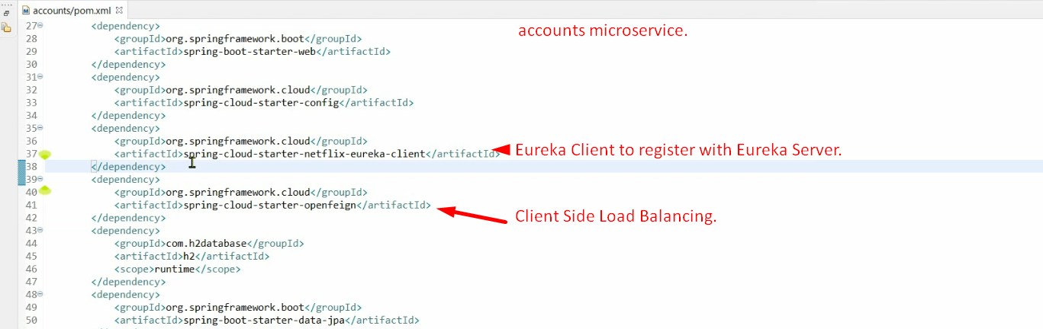
3. application.properties  
   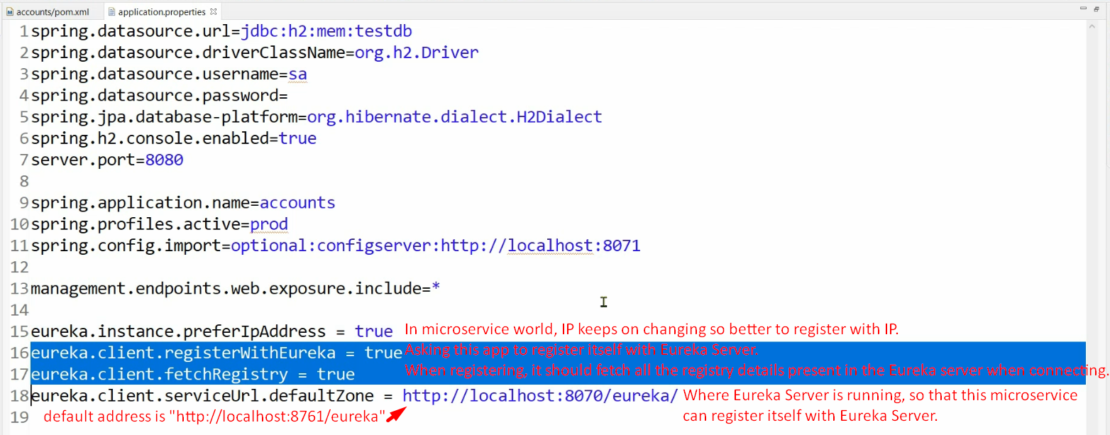  
   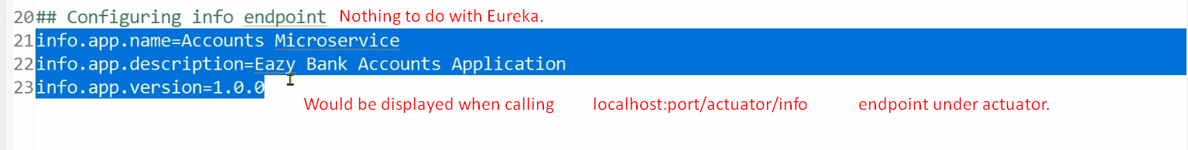
4. 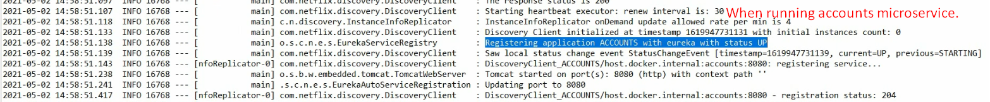
5. 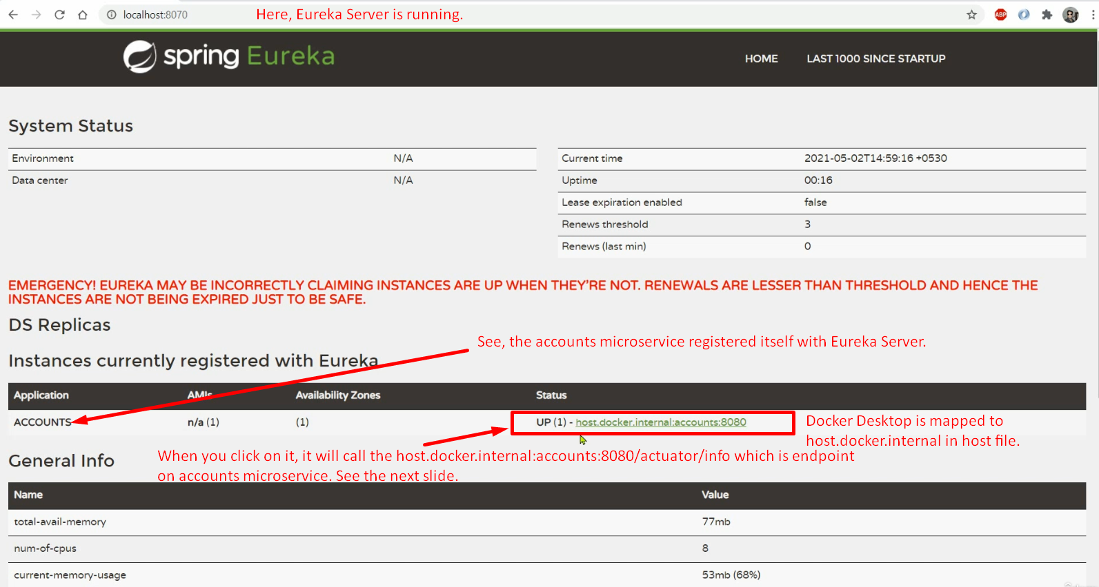
6. 